Analysis of an MCC lung cancer clinical trial data with RPEXE

Gang Han, 06/17/2010

This document reports the analysis of the overall survival (OS) and progression free survival (PFS) for a lung cancer clinical trial conducted at Moffitt Cancer Center. The data are in the appendix, and the MATLAB code is saved in the directory: G:\Projects\HanGang\Piece_wise_Expo\program\matlab_functions\RPEXE_2010_umbrella\example

For both OS and PFS, we have done the following items:
1, Plot the Kaplan-Meier estimate;
2, Plot the normalized spacing and instantaneous failure rate;
3, Run the RPEXE package for all the data and interpret the result;
4, Run the RPEXE package for data starting from the first month and interpret.

Overall Survival

1, Kaplan-Meier estimate
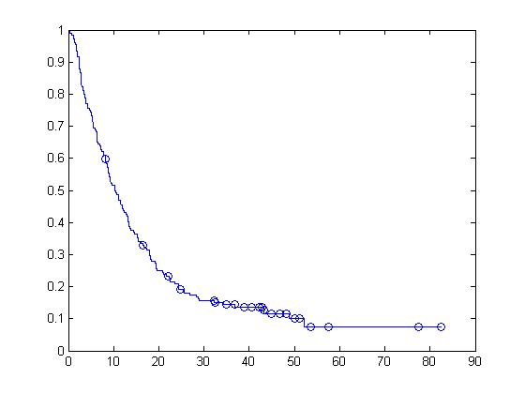

2, Plots of the normalized spacing and hazard rate

2.1: Plot of the normalized spacing vs. time and hazard vs. time
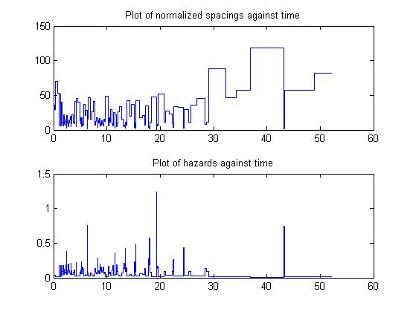

2.2: Plot of the normalized spacing vs. # events and hazard vs. # events
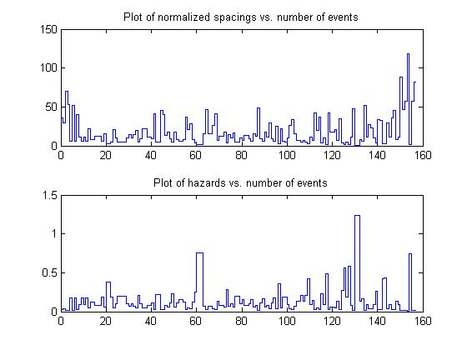

3, RPEXE analysis of the whole data set

- In PAVA, umbrella alternative, the peak of the hazard was chosen at time 6.2781. The Times and P-values given by RPEXE are:
TIMES P-VALUES
% 24.4603 0.9608
% 1.3808 0.8258
% 48.8548 0.7539
% 6.2795 0.7208
% 25.7096 0.6876
% 13.7096 0.6500
% 1.0521 0.4156
% 6.3452 0.4152
% 19.5945 0.1441
% 6.3781 0.0053
% 6.4110 0.1723
% 1.6438 0.0026
% 29.0301 0.0000

- The p-values suggest that the failure rate increases at month 1.64 and decreases at month 29.03.
- The estimated normalized spacing (1 over the failure rate) values are 36.53, 14.46, and 64.62 in time intervals (0, 1.64), (1.64, 29.03), and (29.03, 83).
- The numbers of death are 8, 142, and 7 in the three time intervals.
- Plot of the RPEXE estimate overlaid with Kaplan-Meier estimate:
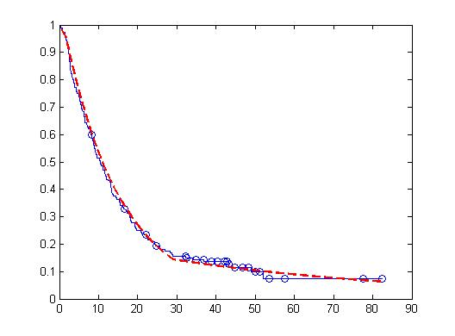

Plot of the normalized spacing vs. time and hazard vs. time, overlaid with the estimate:
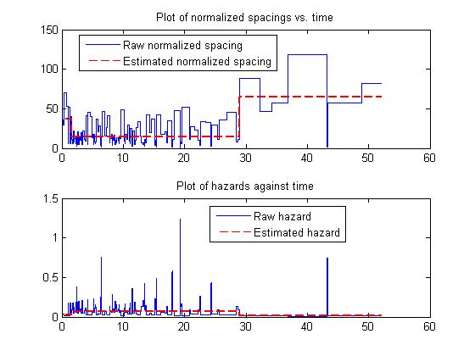
Plot of the normalized spacing vs. # events and hazard vs. # events
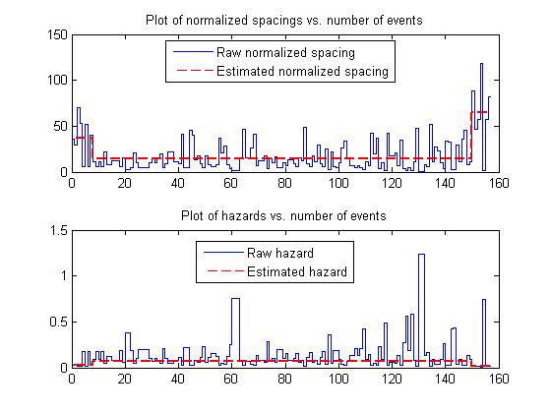

4, RPEXE analysis of the data starting from Month 1 (the clock is set to start at month 1)

- The failure rate drops at month 28.03.
- The estimated normalized spacing (1 over the failure rate) values are 14.74, 64.62 in time intervals (0, 28.03) and (28.03, 82).
- The numbers of death are 147 and 7 in the two time intervals.
- Plot of the RPEXE estimate overlaid with Kaplan-Meier estimate:

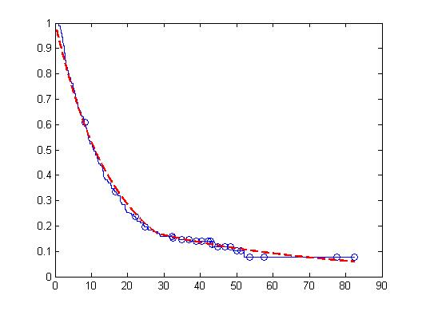

Progression Free Survival

1, Kaplan-Meier estimate

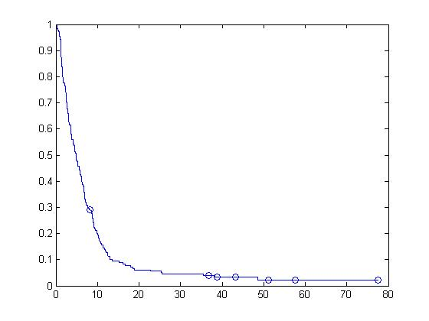

2, Plots of the normalized spacing and hazard rate

2.1: Plot of the normalized spacing vs. time and hazard vs. time
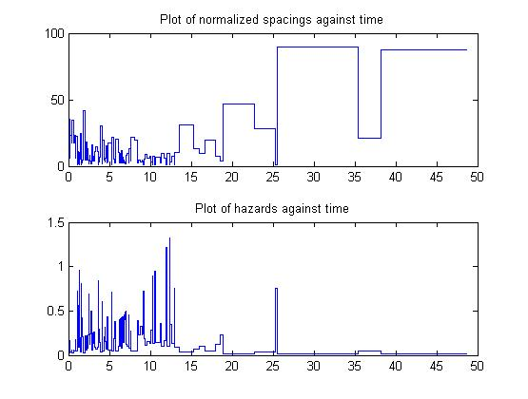
2.2: Plot of the normalized spacing vs. # events and hazard vs. # events
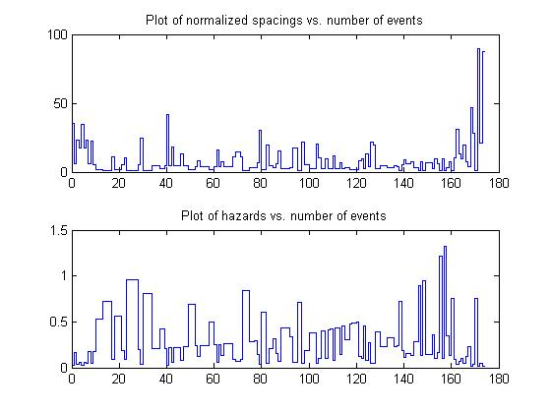
3, RPEXE analysis of the whole data set

- In PAVA, umbrella alternative, the peak of the hazard was chosen at time1.3479. The Times and P-values given by RPEXE are:
TIMES P-VALUES
% 0.6575 0.9882
% 13.5452 0.8331
% 0.8877 0.7069
% 38.2027 0.6974
% 1.0849 0.5259
% 0.1973 0.4686
% 1.7753 0.4658
% 18.8712 0.3488
% 1.3479 0.0410
% 25.4795 0.0236
% 1.3808 0.0053
% 1.0521 0.0000
% 12.9863 0.0000

- The failure rate increases at month 1.05 and decreases at month 12.99.
- The estimated normalized spacing (1 over the failure rate) values are 20.72, 5.70, and 28.56 in time intervals (0, 1.05), (1.05, 12.99), and (12.99, 78).
- The numbers of death are 9, 152, and 13 in the three time intervals.
- Plot of the RPEXE estimate overlaid with Kaplan-Meier estimate:

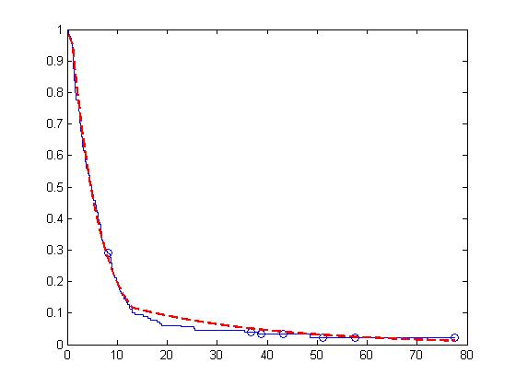

Plot of the normalized spacing vs. time and hazard vs. time, overlaid with the estimate:
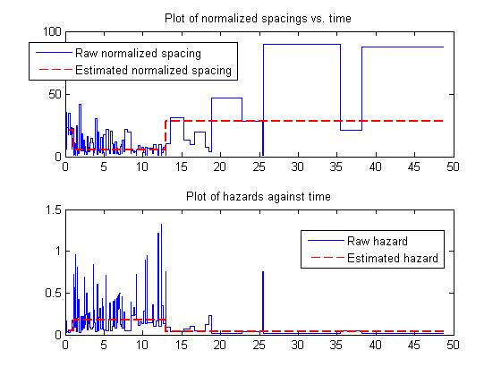
Plot of the normalized spacing vs. # events and hazard vs. # events:
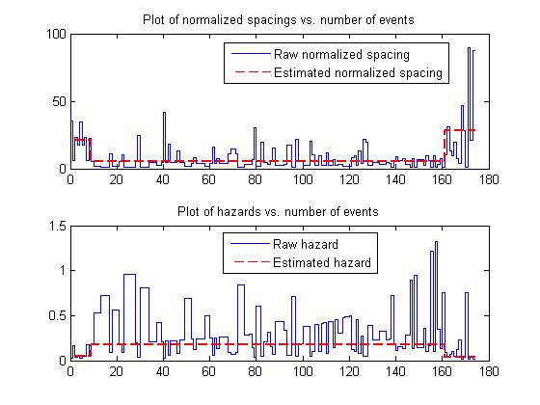

4, RPEXE analysis of the data starting from Month 1 (the clock is set to start at month 1)

- The failure rate drops at month 11.99.
- The estimated normalized spacing (1 over the failure rate) values are 5.72 and 28.56 in time intervals (0, 11.99) and (11.99, 77).
- The numbers of death are 153 and 13 in the two time intervals.
- Plot of the RPEXE estimate overlaid with Kaplan-Meier estimate:

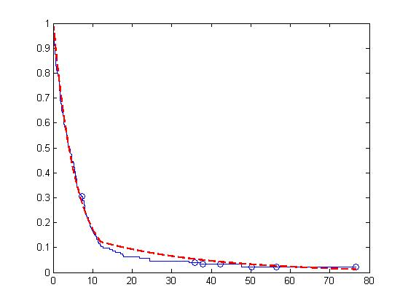

Appendix. The raw data.

We use 0 to denote censoring and 1 to denote event. The four columns are the patient number, censor variable of OS, time of the OS, censor variable of PFS, time of PFS.

NO | CensoredOS | OS | CensoredPFS | PFS
1 | 1 | 3.9123 | 1 | 1.1507
2 | 1 | 4.274 | 1 | 3.5507
3 | 1 | 2.4986 | 1 | 1.6438
4 | 1 | 26.86 | 1 | 8.7781
5 | 0 | 82.455 | 1 | 10.586
6 | 1 | 15.189 | 1 | 0.8877
7 | 1 | 6.937 | 1 | 4.8329
8 | 1 | 6.411 | 1 | 4.5699
9 | 1 | 13.71 | 1 | 9.074
10 | 1 | 17.227 | 1 | 12.395
11 | 1 | 6.3781 | 1 | 4.5041
12 | 1 | 7.7918 | 1 | 4.8329
13 | 1 | 8.9425 | 1 | 1.611
14 | 1 | 3.3205 | 1 | 0.9205
15 | 1 | 1.8082 | 1 | 0.2301
16 | 1 | 2.3014 | 1 | 2.3014
17 | 1 | 48.855 | 1 | 48.625
18 | 1 | 0.1973 | 1 | 0.1973
19 | 0 | 77.523 | 0 | 77.523
20 | 1 | 6.411 | 1 | 5.063
21 | 1 | 5.8849 | 1 | 5.2932
22 | 1 | 10.685 | 1 | 5.6877
23 | 1 | 3.0575 | 1 | 1.611
24 | 1 | 16.438 | 1 | 11.047
25 | 1 | 0.7562 | 1 | 0.7562
26 | 1 | 0.3616 | 1 | 0.3616
27 | 1 | 19.299 | 1 | 9.337
28 | 1 | 5.2274 | 1 | 4.8658
29 | 1 | 1.7425 | 1 | 1.7425
30 | 1 | 18.312 | 1 | 12.921
31 | 1 | 2.6301 | 1 | 2.6301
32 | 1 | 2.4658 | 1 | 1.611
33 | 1 | 5.1945 | 1 | 3.7479
34 | 1 | 13.184 | 1 | 8.0548
35 | 1 | 7.8575 | 1 | 6.2466
36 | 1 | 15.452 | 1 | 10.29
37 | 1 | 2.8274 | 1 | 2.8274
38 | 1 | 20.745 | 1 | 3.7808
39 | 1 | 19.299 | 1 | 9.1726
40 | 1 | 19.595 | 1 | 10.553
41 | 1 | 1.9726 | 1 | 1.0521
42 | 1 | 11.77 | 1 | 4.8329
43 | 1 | 6.5425 | 1 | 4.1425
44 | 1 | 5.5233 | 1 | 2.5315
45 | 0 | 8.2192 | 0 | 8.2192
46 | 1 | 36.855 | 1 | 18.871
47 | 0 | 51.189 | 0 | 51.189
48 | 1 | 52.077 | 1 | 6.0493
49 | 0 | 53.622 | 1 | 25.479
50 | 1 | 13.447 | 1 | 11.277
51 | 1 | 10.29 | 1 | 4.7342
52 | 1 | 25.71 | 1 | 10.323
53 | 0 | 48.296 | 1 | 12
54 | 1 | 18.049 | 1 | 3.189
55 | 1 | 12.033 | 1 | 10.29
56 | 1 | 29.03 | 1 | 2.5644
57 | 1 | 12.789 | 1 | 9.2055
58 | 1 | 11.112 | 1 | 6.9699
59 | 1 | 2.4329 | 1 | 1.1178
60 | 0 | 46.816 | 1 | 11.737
61 | 1 | 15.419 | 1 | 7.3644
62 | 1 | 2.9918 | 1 | 2.4986
63 | 0 | 42.805 | 1 | 18.542
64 | 1 | 11.474 | 1 | 5.5562
65 | 0 | 44.877 | 1 | 3.6822
66 | 1 | 2.7288 | 1 | 1.3808
67 | 0 | 43.299 | 0 | 43.299
68 | 1 | 8.7781 | 1 | 8.7781
69 | 1 | 13.348 | 1 | 7.0356
70 | 1 | 8.8767 | 1 | 3.5507
71 | 1 | 18.082 | 1 | 10.816
72 | 1 | 23.441 | 1 | 11.967
73 | 1 | 28.373 | 1 | 12.427
74 | 1 | 25.348 | 1 | 6.6082
75 | 1 | 11.507 | 1 | 1.2493
76 | 1 | 10.356 | 1 | 6.7726
77 | 1 | 8.5151 | 1 | 8.5151
78 | 1 | 2.0712 | 1 | 2.0712
79 | 1 | 14.63 | 1 | 11.375
80 | 1 | 6.411 | 1 | 6.411
81 | 1 | 7.4301 | 1 | 3.1233
82 | 1 | 24.395 | 1 | 5.7534
83 | 1 | 17.951 | 1 | 8.9753
84 | 1 | 11.836 | 1 | 1.3808
85 | 1 | 8.0877 | 1 | 3.1233
86 | 0 | 34.849 | 1 | 22.784
87 | 1 | 34.258 | 1 | 8.9753
88 | 1 | 19.266 | 1 | 9.5671
89 | 0 | 32.449 | 1 | 17.984
90 | 1 | 2.6959 | 1 | 2.6959
91 | 1 | 9.3699 | 1 | 7.3265
92 | 1 | 3.8466 | 1 | 3.8466
93 | 1 | 1.8411 | 1 | 0.4603
94 | 1 | 5.3589 | 1 | 1.2493
95 | 1 | 11.014 | 1 | 1.2164
96 | 1 | 22.192 | 1 | 9.8959
97 | 1 | 6.3452 | 1 | 3.6822
98 | 1 | 9.6658 | 1 | 2.5315
99 | 1 | 7.2 | 1 | 4.4712
100 | 1 | 8.6795 | 1 | 1.3808
101 | 1 | 11.178 | 1 | 6.9041
102 | 1 | 13.249 | 1 | 4.4712
103 | 1 | 14.334 | 1 | 5.6219
104 | 1 | 9.2055 | 1 | 1.4137
105 | 1 | 10.553 | 1 | 4.1753
106 | 1 | 4.274 | 1 | 1.611
107 | 1 | 2.3342 | 1 | 2.3342
108 | 0 | 50.038 | 1 | 3.0575
109 | 1 | 5.5233 | 1 | 2.1041
110 | 1 | 21.633 | 1 | 13.545
111 | 1 | 2.4658 | 1 | 2.4329
112 | 1 | 43.332 | 1 | 6.937
113 | 1 | 16.734 | 1 | 7.0027
114 | 1 | 2.3014 | 1 | 1.7753
115 | 1 | 21.008 | 1 | 9.8959
116 | 1 | 9.074 | 1 | 5.2603
117 | 0 | 46.784 | 1 | 7.1671
118 | 1 | 8.7781 | 1 | 6.4438
119 | 1 | 8.2521 | 1 | 5.7863
120 | 1 | 12.986 | 1 | 12.986
121 | 1 | 6.0493 | 1 | 3.6493
122 | 1 | 8.2849 | 1 | 2.9918
123 | 1 | 4.8986 | 1 | 1.5781
124 | 1 | 10.192 | 1 | 6.1808
125 | 1 | 19.463 | 1 | 1.7425
126 | 1 | 17.852 | 1 | 8.4164
127 | 1 | 32.318 | 1 | 3.6822
128 | 1 | 8.0877 | 1 | 1.2822
129 | 0 | 42.181 | 1 | 2.7616
130 | 1 | 13.414 | 1 | 1.3808
131 | 1 | 13.611 | 1 | 6.3781
132 | 1 | 1.0521 | 1 | 0.6575
133 | 1 | 9.3041 | 1 | 6.2137
134 | 1 | 24.46 | 1 | 8.9753
135 | 1 | 3.8466 | 1 | 3.1562
136 | 1 | 3.3863 | 1 | 1.3479
137 | 1 | 6.2795 | 1 | 4.1753
138 | 1 | 2.8932 | 1 | 1.1178
139 | 1 | 3.6822 | 1 | 2.4986
140 | 1 | 2.7945 | 1 | 2.7945
141 | 1 | 22.455 | 1 | 6.8055
142 | 1 | 1.6438 | 1 | 1.1507
143 | 1 | 5.1288 | 1 | 2.663
144 | 1 | 11.901 | 1 | 5.7205
145 | 1 | 22.553 | 1 | 6.674
146 | 1 | 16.142 | 1 | 12.559
147 | 0 | 57.534 | 0 | 57.534
148 | 1 | 9.5342 | 1 | 6.9041
149 | 1 | 12.362 | 1 | 4.8329
150 | 0 | 16.537 | 1 | 8.5151
151 | 1 | 43.233 | 1 | 35.408
152 | 1 | 13.184 | 1 | 2.5315
153 | 0 | 42.115 | 1 | 38.203
154 | 1 | 28.636 | 1 | 6.674
155 | 0 | 40.471 | 1 | 16.044
156 | 1 | 2.0712 | 1 | 1.7096
157 | 1 | 8.4164 | 1 | 2.9589
158 | 1 | 4.2082 | 1 | 2.2356
159 | 1 | 1.0849 | 1 | 1.0849
160 | 1 | 17.918 | 1 | 8.7781
161 | 1 | 3.1562 | 1 | 1.6767
162 | 1 | 17.096 | 1 | 7.6603
163 | 1 | 3.2877 | 1 | 3.2877
164 | 1 | 1.7096 | 1 | 1.1507
165 | 1 | 24.329 | 1 | 10.093
166 | 1 | 2.3014 | 1 | 2.3014
167 | 1 | 15.255 | 1 | 15.255
168 | 1 | 4.9973 | 1 | 2.7288
169 | 0 | 22.093 | 1 | 7.5945
170 | 1 | 5.589 | 1 | 5.2932
171 | 1 | 1.3808 | 1 | 1.1178
172 | 1 | 7.0685 | 1 | 1.3808
173 | 1 | 1.4137 | 1 | 1.1507
174 | 1 | 2.7945 | 1 | 2.7945
175 | 0 | 38.893 | 0 | 38.893
176 | 1 | 3.6822 | 1 | 1.2493
177 | 0 | 36.822 | 0 | 36.822
178 | 1 | 5.4247 | 1 | 3.7479
179 | 0 | 24.822 | 1 | 16.668
180 | 1 | 4.6027 | 1 | 4.3726
181 | 0 | 32.219 | 1 | 25.348

